PROJECT DOCUMENTATION
WhatsApp Chatbot
Lead Qualification & Appointment Booking System
━━━━━━━━━━━━━━━━━━━━━━
GoHighLevel • n8n • WhatsApp • Calendar

⚙ | Workflow Steps — Step-by-Step Breakdown

1 | Lead Creation
If a lead does not already exist, the system creates a new lead in GHL to initiate the conversation and track all interactions.
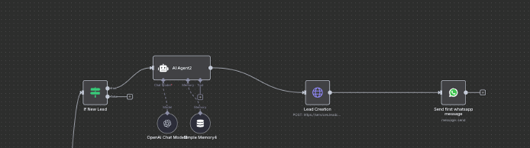

2 | Lead Update with Name
If the user does not provide their name, the system asks for the name again and performs name validation. Once the name is successfully collected, the conversation state is updated to Email Collection.
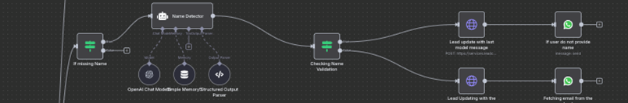

3 | Email Collection and Validation
The system asks the user for their email address and validates it. If the user does not provide an email, the system requests it again. Once a valid email is provided, the conversation stage is updated to Lead Qualification — Need Qualification.
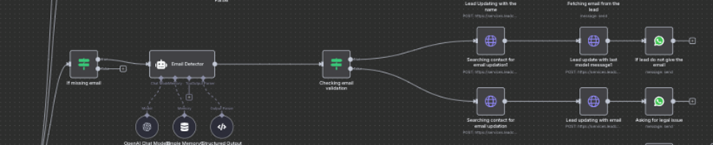

4 | Need Qualification Stage
Once the lead's name and email are stored in GHL, the conversation moves to the Need Qualification stage. If the lead is not qualified, they are redirected to a free resource and the lead status is updated to Need Unqualified. If the lead's need is unclear, the system asks for additional clarification. If the need is qualified, the conversation stage is updated to Ownership Qualification.
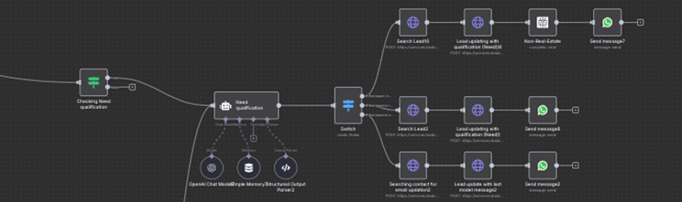

5 | Ownership Qualification Stage
Once the lead is qualified in the previous Need Qualification stage, the conversation proceeds to the Ownership Qualification stage. If the lead is unqualified for ownership, they are redirected to a free resource and the lead status is updated to Ownership Unqualified. If ownership information is unclear, the system asks the lead to clarify their relationship to the property. If the lead is qualified for ownership, the conversation stage is updated to Timing Qualification.
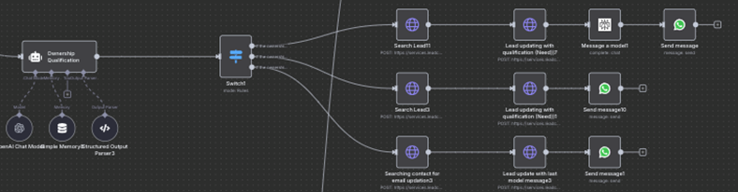

6 | Timing Qualification Stage
Once the lead enters the Timing Qualification stage, the system asks about timing — e.g. "Could you please let us know when you are hoping to take action or resolve this issue?" If the timing is unqualified, the lead status is updated to Timing Unqualified and the lead is redirected to free resources. If the lead is qualified, the conversation stage is updated to Property Qualification. If the timing is unclear, the system asks for clarification again.
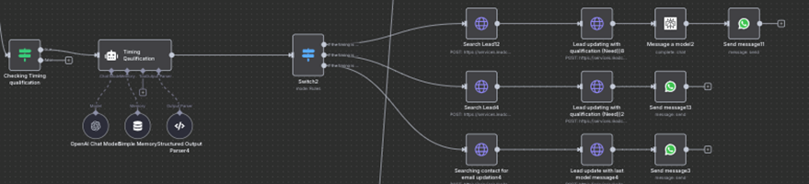

7 | Property Qualification Stage
Once the lead enters the Property Qualification stage, the system asks about property details to determine qualification. If the property value is unqualified, the lead is redirected to free resources and the lead status is updated to Property Value Unqualified. If the lead is qualified based on the property value, the conversation stage is updated to the Offer Appointment stage. If the property value is unclear, the system asks the property qualification question again.
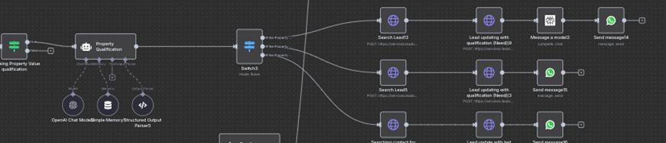

8 | Appointment Booking Stage
Once the lead has passed all previous qualifications, the system asks the lead to book an appointment. If the lead wants to book an appointment, the system provides available free slots from the calendar and asks the lead to choose the slot that suits them best. Once the lead selects a slot, the appointment is booked and the lead conversation stage is updated to Meeting Booked.
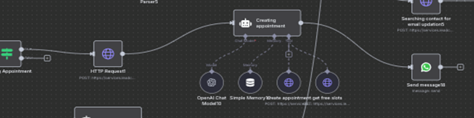

9 | Post-Booking Conversation Stage
Once the conversation stage is Meeting Booked, the assigned agent handles any further interactions. If the lead wants to book another meeting, the agent updates the conversation stage back to Need Qualification and asks the same qualification questions again. If the lead does not want another meeting, the agent provides the company's link and asks the lead to visit the link to learn more about the services.
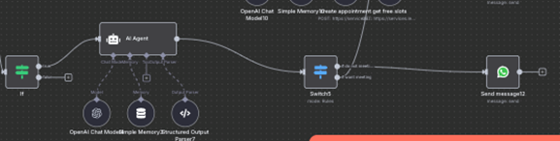

10 | Main Workflow Summary

The WhatsApp chatbot workflow is designed to efficiently capture, qualify, and engage leads, seamlessly integrated with GoHighLevel (GHL), where all lead creation and updates occur in real time. The workflow begins by creating a new lead in GHL if one does not already exist, then collects and validates the lead's name and email, updating the conversation stage at each step.
Once basic information is collected, the system proceeds through a series of qualification stages: Need Qualification, Ownership Qualification, Timing Qualification, and Property Qualification. At each stage, leads are either progressed if qualified, redirected to free resources if unqualified, or asked for clarification if information is unclear. After passing all qualification stages, the system guides the lead to book an appointment, offering available calendar slots and confirming the selected time.
In the Post-Booking Conversation stage, the assigned agent manages further interactions, either re-qualifying the lead for additional meetings or providing the company link for service information. This structured workflow ensures that all leads are systematically validated, engaged, and smoothly transitioned through each stage, with conversation stages and lead statuses updated automatically in GHL.
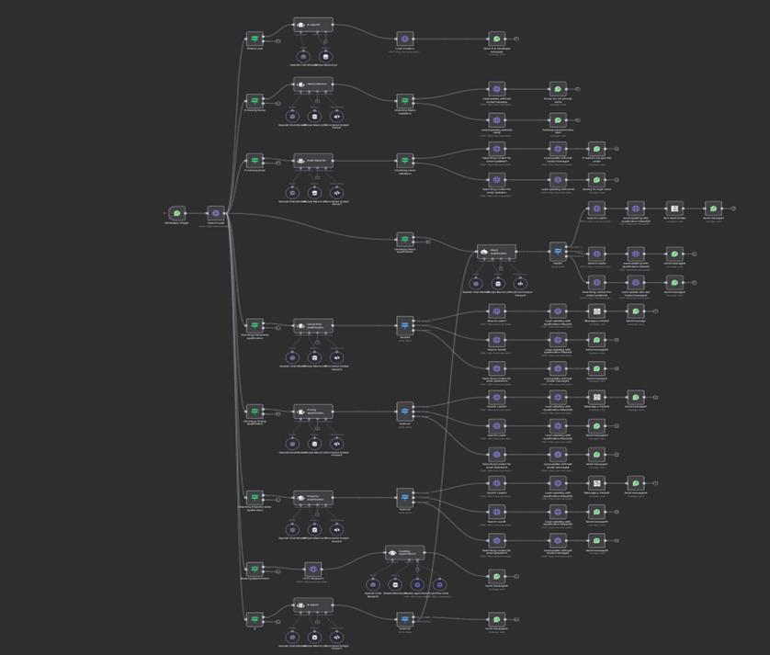
Figure: Complete WhatsApp Chatbot Workflow — Full Pipeline Overview
11 | Follow-Up for Non-Responsive Leads
If the lead does not reply within 5 minutes, the system sends a follow-up message according to the predefined workflow to re-engage the lead.
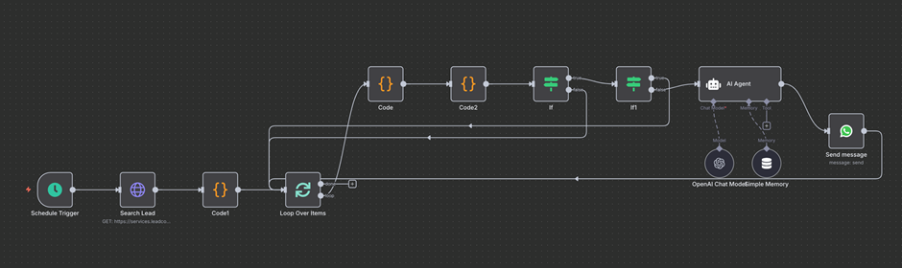

12 | Appointment Reminders
The system sends appointment reminders to the lead 24 hours and 2 hours before the scheduled meeting. This feature is pending completion, as the reminder message templates are not yet finalised.
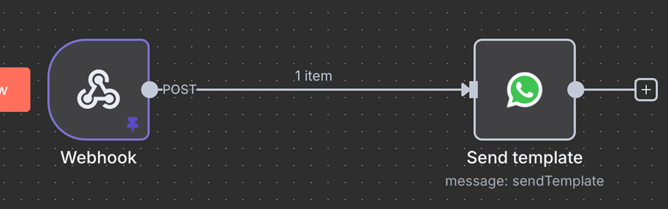

13 | No-Show Lead Follow-Up
The system sends a predefined template message to leads who do not show up for their scheduled appointment to re-engage them.
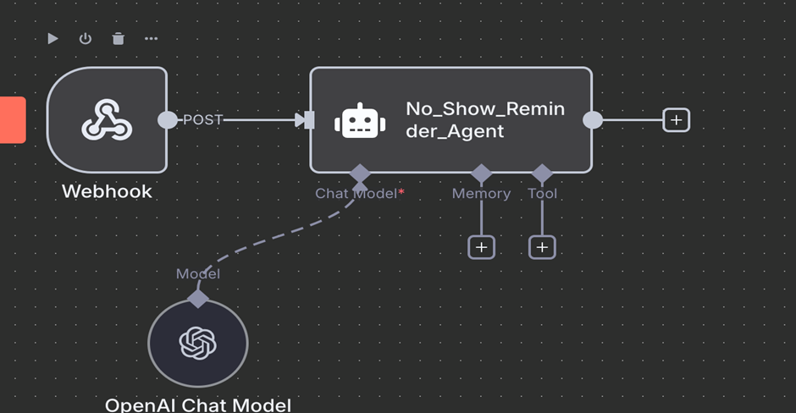

14 | GHL Workflow Integrations via Webhook
All relevant GHL workflows send lead data to n8n via webhook. This includes sending reminders 24 hours and 2 hours before a scheduled meeting, updating the lead's conversation stage and lead status to Meeting Booked when a meeting is successfully booked, and sending data for no-show leads to n8n for follow-up actions.
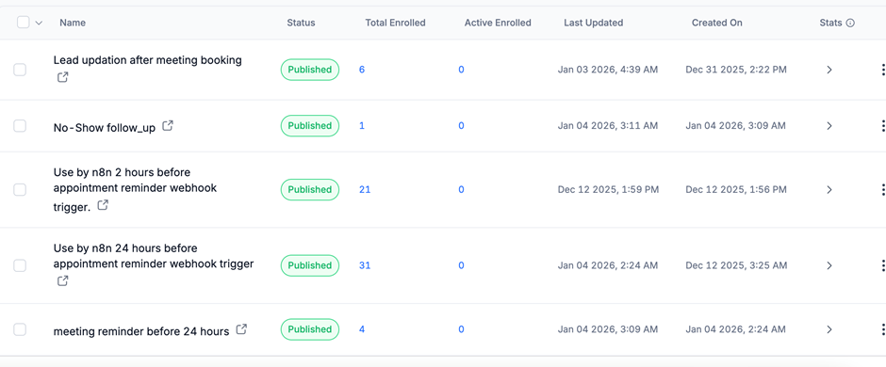

✓ | Final Delivered Project

The WhatsApp chatbot project has been successfully developed and delivered with seamless integration into GoHighLevel (GHL), ensuring that all lead creation, updates, and conversation stage transitions occur in real time.
The system captures leads, validates key information such as name and email, and progresses them through a structured series of qualification stages: Need Qualification, Ownership Qualification, Timing Qualification, and Property Qualification. Qualified leads are guided to book appointments via available calendar slots, with confirmed bookings updating both the conversation stage and lead status to Meeting Booked in GHL.
The workflow also includes:
- Automated follow-ups for non-responsive leads (after 5 minutes)
- Appointment reminders 24 hours and 2 hours prior to scheduled meetings (pending template finalisation)
- No-show follow-ups through predefined templates
- All relevant GHL workflows integrated via webhook to n8n for efficient data transfer and automated lead management

This delivered system ensures that leads are efficiently captured, qualified, engaged, and tracked throughout the entire lifecycle, providing a fully automated and professional client engagement solution.

⚠ | Pending Items — Client Action Required

The following workflows are not yet fully completed because they require input from the client in the form of message templates:
⚠ Action Required 1: No-Show Lead Follow-Up Workflow
The system is ready to send a predefined template message to leads who do not attend their scheduled appointments, but the actual message template needs to be created in the client's developer account.

⚠ Action Required 2: Appointment Reminders
Reminders to leads 24 hours and 2 hours before a scheduled meeting are pending, as the reminder message templates have not yet been provided.

Once the client provides the required meta message templates in their developer account, these workflows can be fully implemented, enabling the chatbot to send reminders and no-show follow-ups automatically.

End of Document

